**Module-2 Assignment**

**1.Launched an instance and named as Assignment-2 in N.Virginia.**

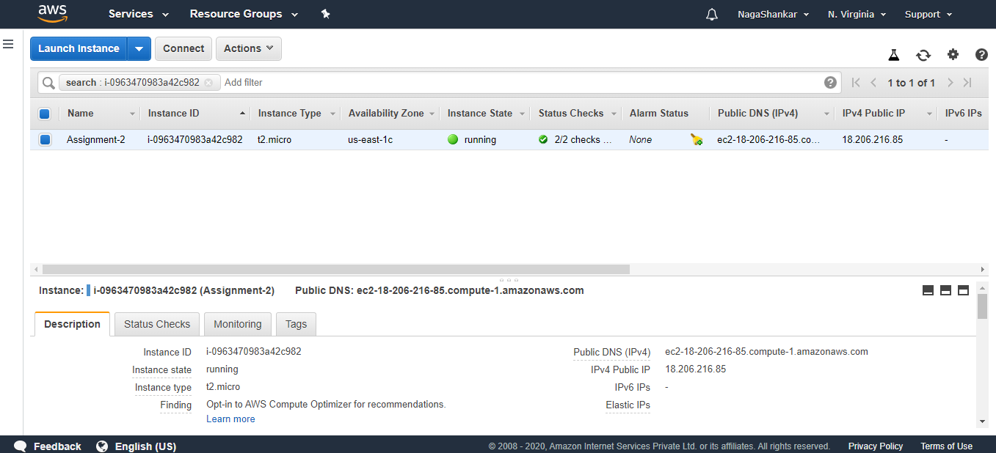

**Logged into Linux Machine is created using Putty**

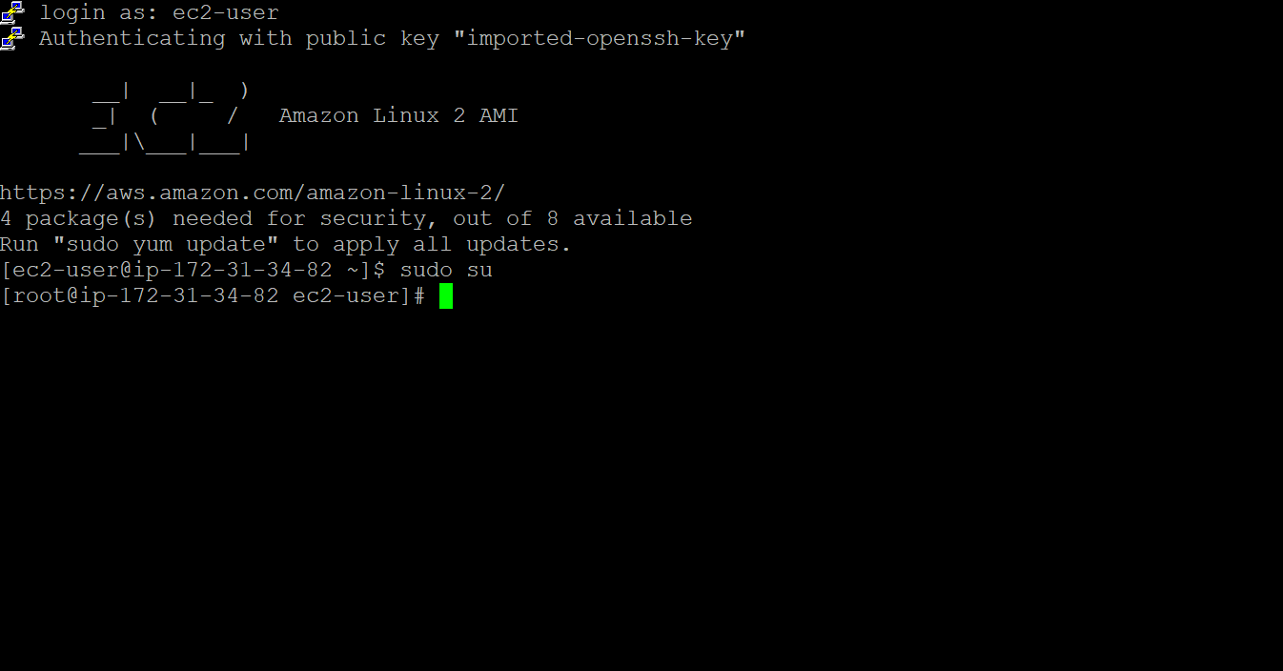

**HTTPD Web service is started**

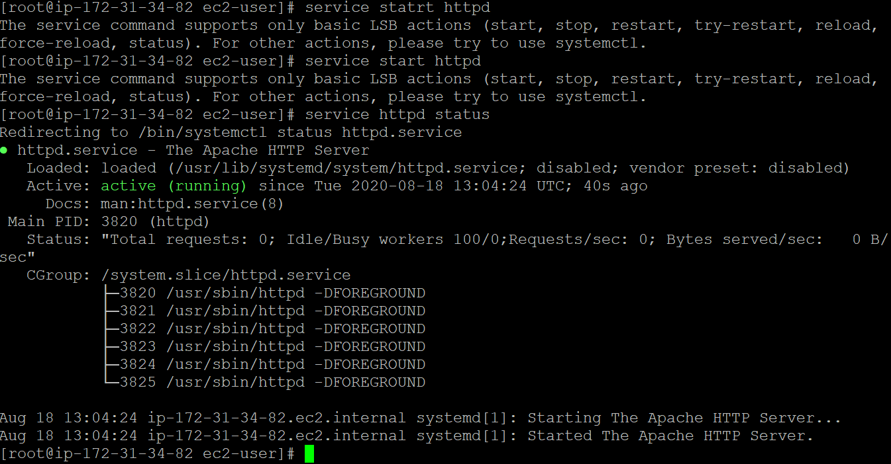

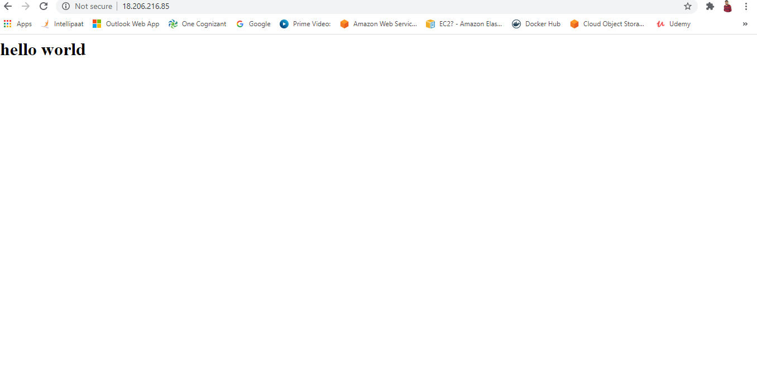

Creating an AMI in Oregan

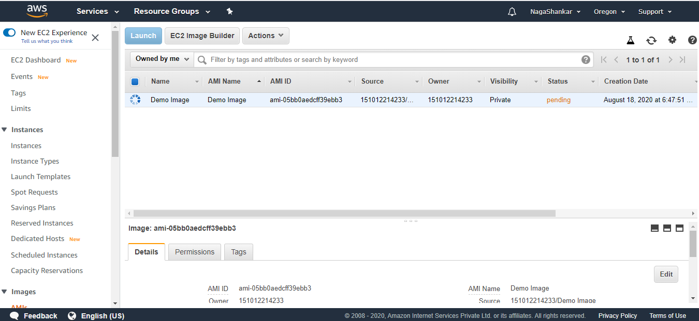

Two EBS with 10GB are attached to the Linux machine

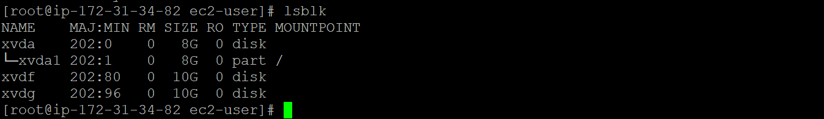

EBSs are mounted with the respective directories....

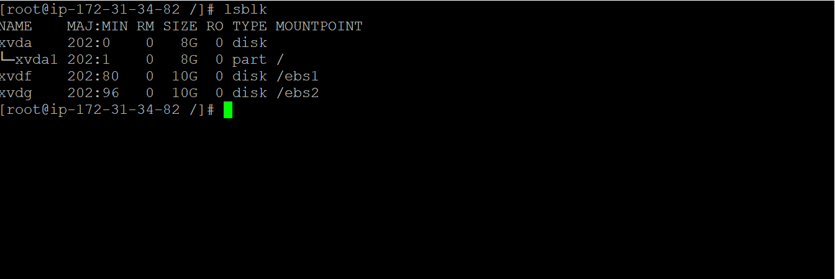

One EBS volume is deleted and the second EBS size is increased by 1GB

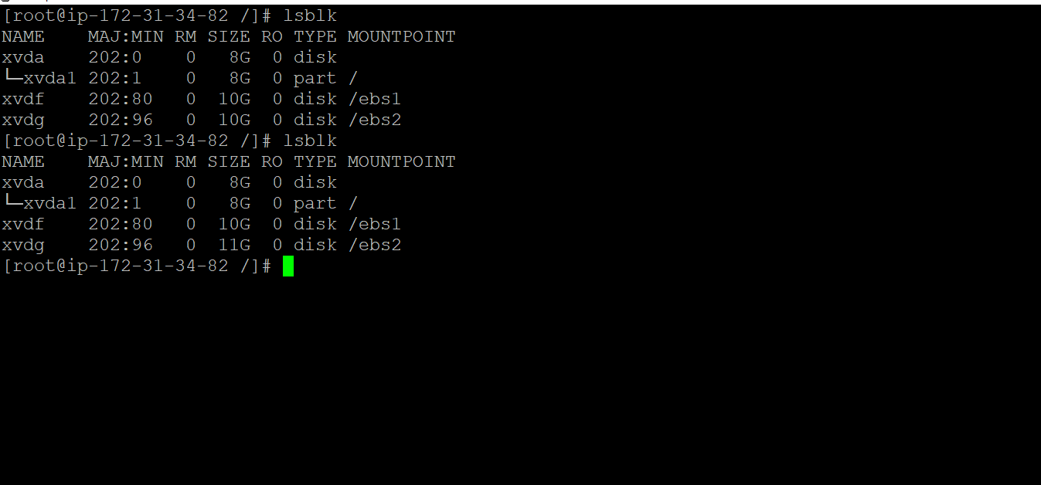

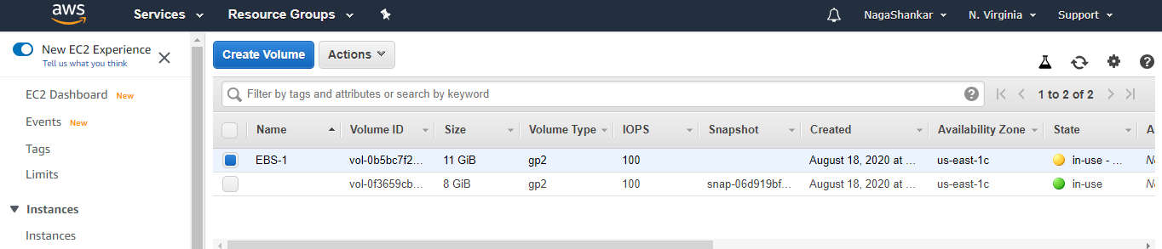

Snapshot is created for the existing EBS

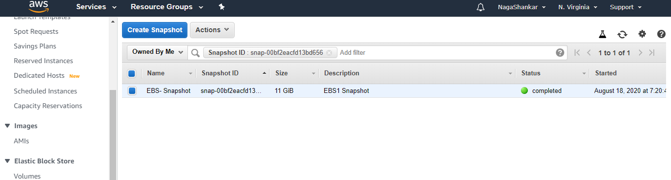

Commands Used In Linux machine

1)vi index.html---to create an html file in cd/var/www/html path

<h1>

Hello world

</h1>

2)lsblk----to find the volumes attached

3)mkfs –t ext4 /dev/xdvf

4)mkfs –t ext4 /dev/xdvg

To create the file systems

5)cd /

mkdir ebs1

mount /dev/xvdf /ebs1

6)cd /

mkdir ebs2

mount /dev/xvdg/ebs2

to mount the volumes

7)df –kh -----show the partitions of the volumes that are present.